SALESMAN MODULE

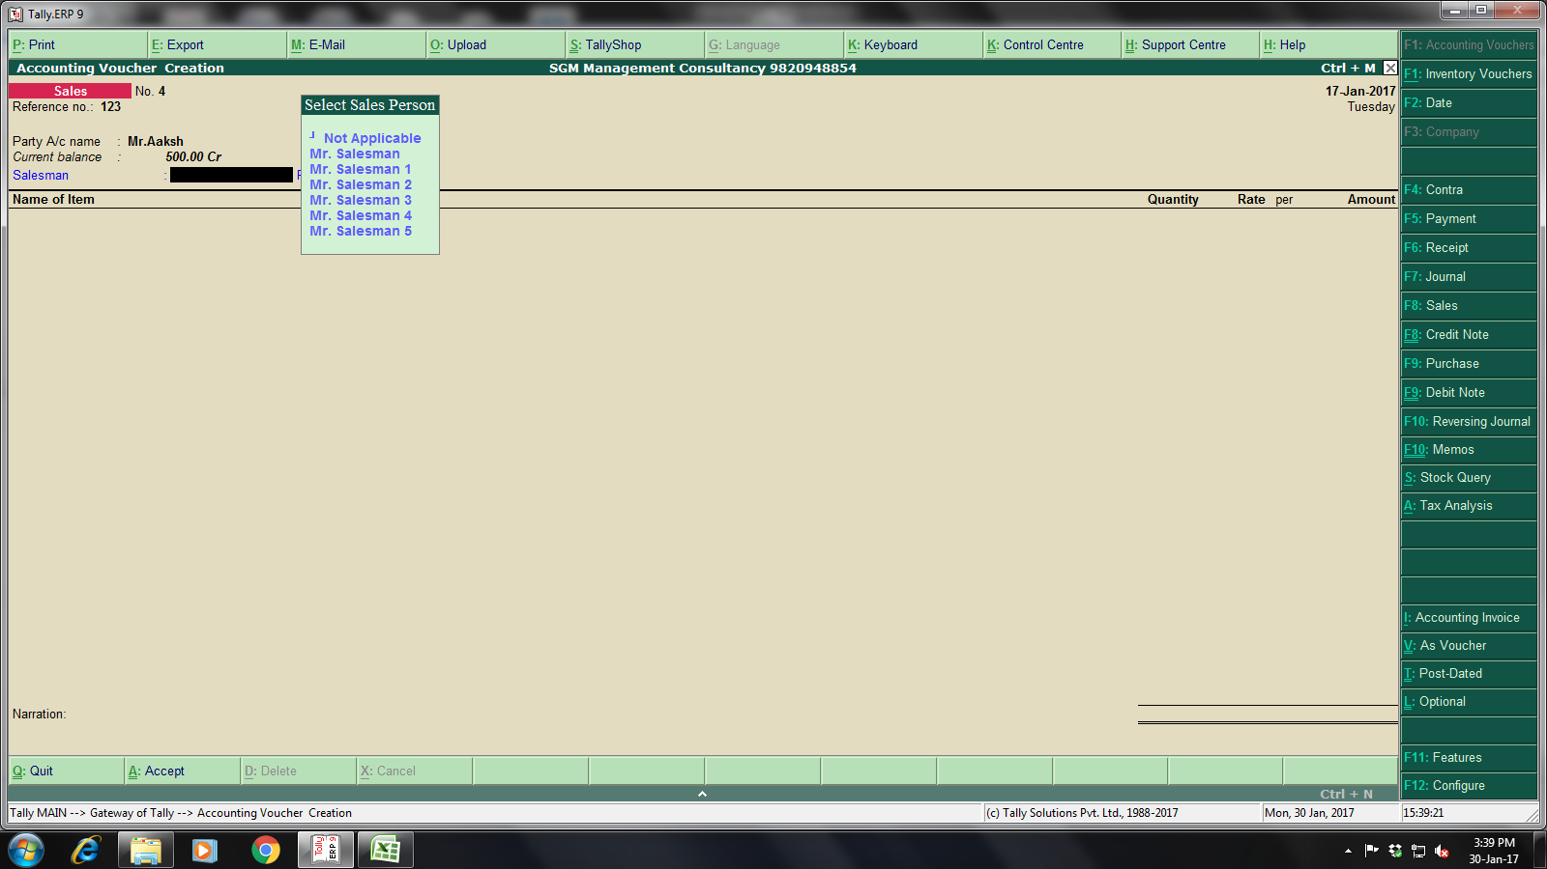
Select Salesman

